PDF – Password Protecting a document

Actions
- Select the PDF that you want to password protect

- Go to https://smallpdf.com/protect-pdf
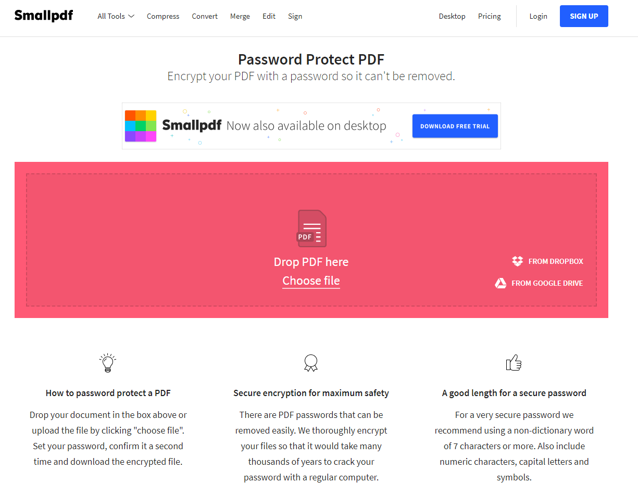

- Drag and drop the pdf file you had selected earlier into the box on the smallpdf site
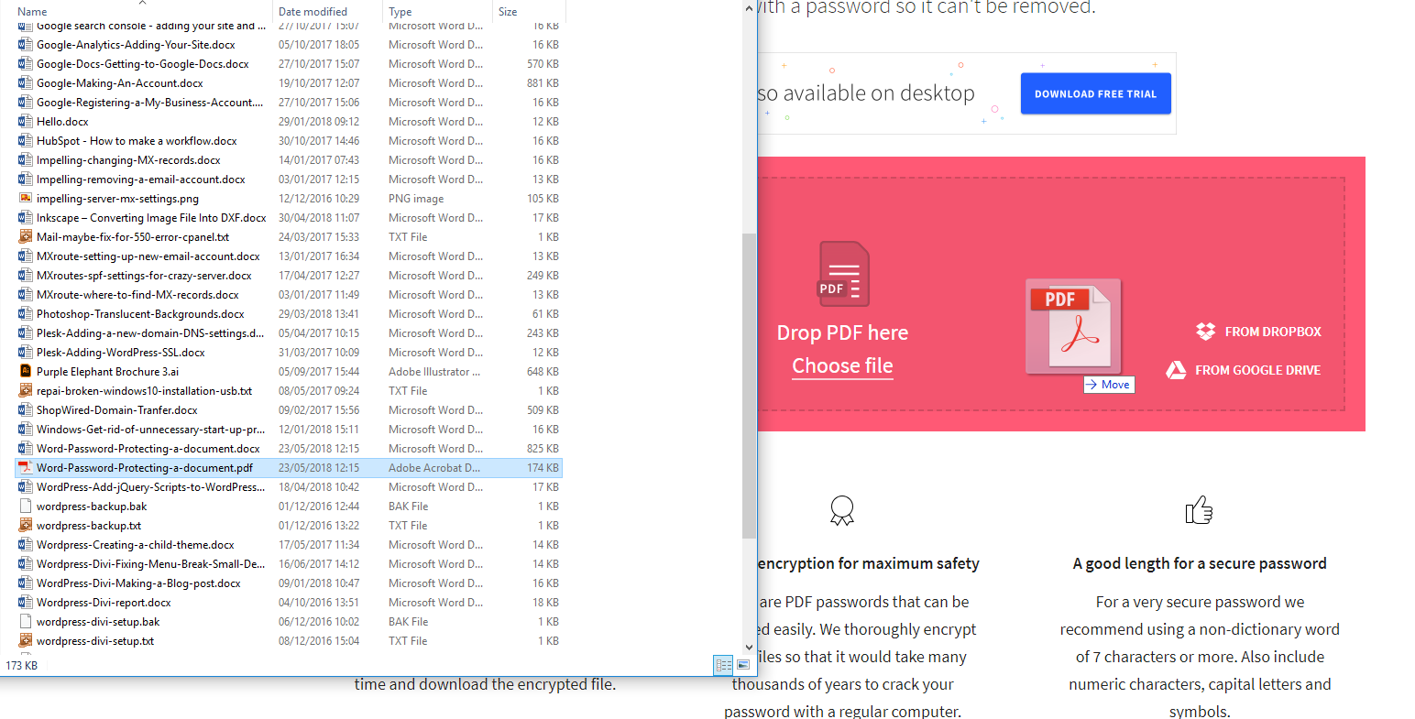

- Type in the password you want use. Then retype it and keep a note of it with a reference to the file. Click ENCRYPT PDF.
- Download the PDF file

- Open the file and type in the password
- Done

Information
These are the other websites you can use if you hit the upload limit.
https://www.sodapdf.com/password-protect-pdf/
https://foxyutils.com/protectpdf/

