Word – Password Protecting a document

Actions
- Open the document you want password protect
- Click File which is located at the top left of the screen

- Click Protect document

- Click Encrypt with Password

- Type in the password you want use and keep a note of it with a reference to the file
- Re-enter the password to confirm it

- When opening the document, it will request the password. Type in the password and click Ok
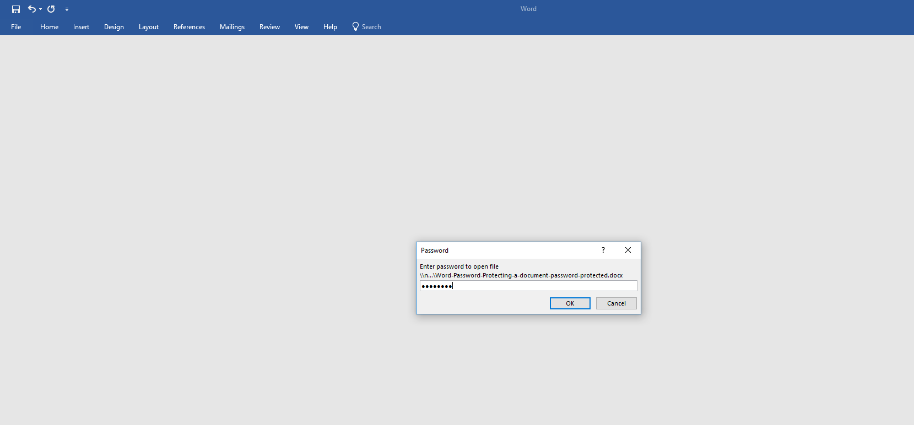
- Done

